**1.Write a python program to test a given number is prime or not.**

**Program:**

|  |
| --- |
| a = int(input("Enter the number to check if it is a prime : ")) |
|  |  | |
|  | if a > 1: | |
|  | for i in range(2, a): | |
|  | if (a % i) == 0: | |
|  | print(a, " is not a prime number") | |
|  | Break | |
|  | else: | |
|  | print(a, " is a prime number") | |
|  | else: | |
|  | print(a, " is neither prime nor composite") | |
|  |  | |
|  |  | |
| **Output:** | |

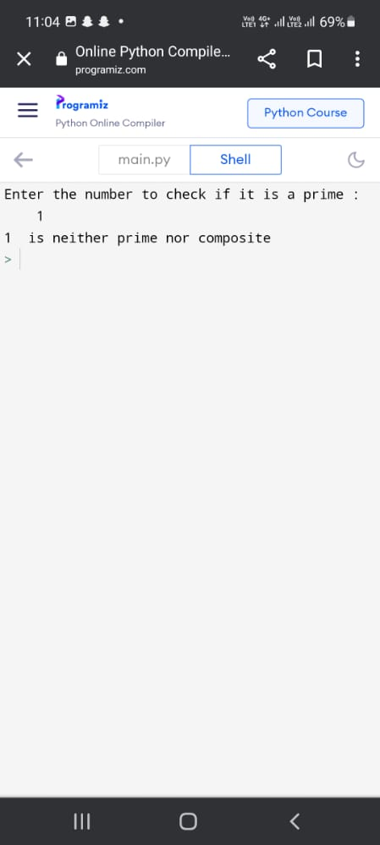

2.Write a python program to generate Fibonacci series.

Program:

|  |
| --- |
| a=0 |
|  | b = 1 |
|  |  |
|  | n = int(input("Enter the range of fibonacci numbers you wish to find")) |
|  |  |
|  | print(a) |
|  | print(b) |
|  |  |
|  | for i in range(0,n-2): |
|  | fib = a + b |
|  | print(fib) |
|  | a = b |
|  | b = fib |
|  | i = i + 1 |

**Output:**

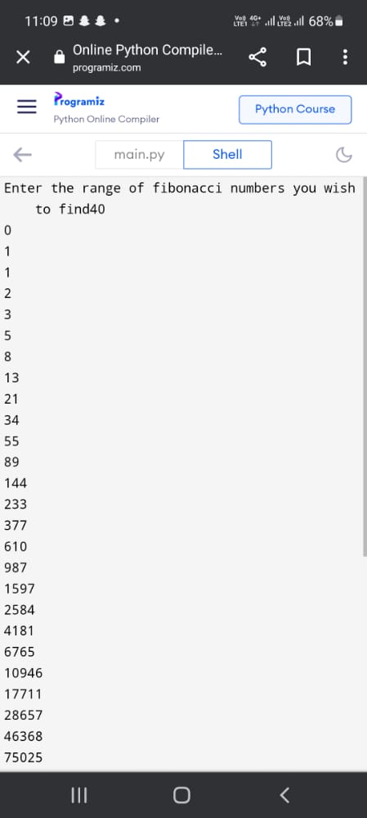

**3.Write a python program to find prime numbers within the range.**

**Program:**

|  |
| --- |
|  |
|  |  |
|  | **a = int(input("Enter the lower bound: "))** |
|  | **b = int(input("Enter the upper bound: "))** |
|  |  |
|  | **for i in range(a,b+1):** |
|  | **if i > 1:** |
|  | **for j in range(2, i):** |
|  | **if (i % j) == 0:** |
|  | **Break** |
|  | **else:** |
|  | **print(i , " is a prime number")** |
|  | **else:** |
|  | **print(i , " is neither prime nor composite")** |

**Output:**

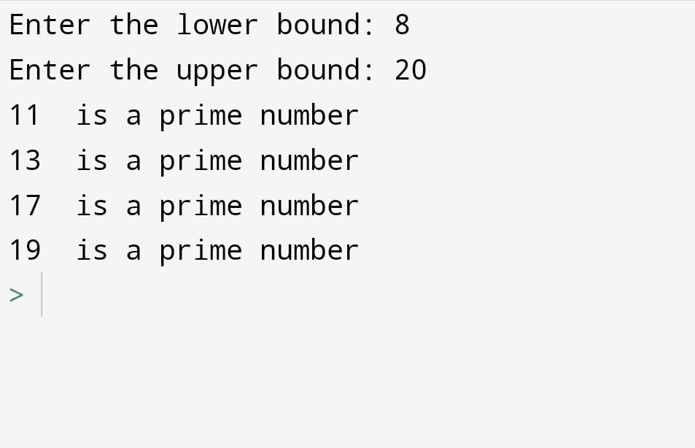

**4.Write a python program to odd numbers in while loop.**

**Program:**

|  |
| --- |
| **print("Finding odd numbers in a given range....")** |
|  |  |
|  | **m = int(input("From : "))** |
|  | **n = int(input("To :"))** |
|  |  |
|  | **while m < n+1:** |
|  | **if(m%2)!=0:** |
|  | **print("{} is a odd number".format(m))** |
|  | **m = m + 1** |
|  |  |
| **Output:** |  |

